3.12.1 - Python Console by tools
Python Console 1
Console Menu 2
Toggle Full screen Area 2
Toggle Maximize Area 2
Duplicate Area into new Window 2
Zoom Text Out 3
Zoom Text In 3
Languages 3
Paste 3
Copy 3
Copy as Script 3
Clear Line 3
Clear 3
Console Execute 3
Edit Menu 4
History Cycle 4
Delete 4
Next character 4
Previous Character 4
Next Word 4
Previous Word 4
Cursor to Next character 4
Cursor to Previous Character 5
Cursor to Line End 5
Cursor to Line Begin 5
Cursor to Next word 5
Cursor to Previous word 5
Unindent 5
Indent 5
Autocomplete 5
Usage 6
Accessing Built-in Python Console 6
First look at the Console Environment 6
Auto Completion at work 6
Before tinkering with the modules.. 7
Examples 8
bpy.context 8
Try it out! 8
bpy.data 9
Try it out! 9
Exercise 10
bpy.ops 10
Try it out! 10

Python Console

The Python console is a quick way to execute commands, with access to the entire Python API, command history and auto-complete. It's a research tool for addon- and script developers. But also a place to quickly execute single operators or to try out some simple code.

Console Menu

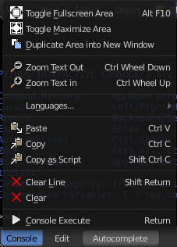
The Console menu provides some console editor window specific functionality.

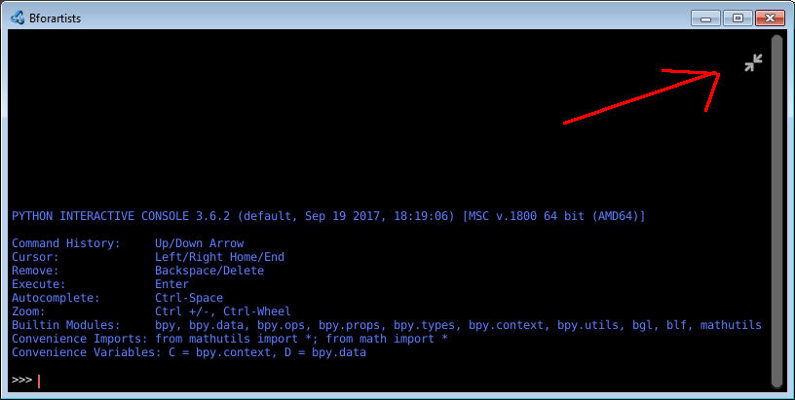
Toggle Full screen Area
Displays the editor maximized without menus.
To return from the full screen view press hotkey Alt F10, or use the little button that appears up right when you move the mouse in this corner.

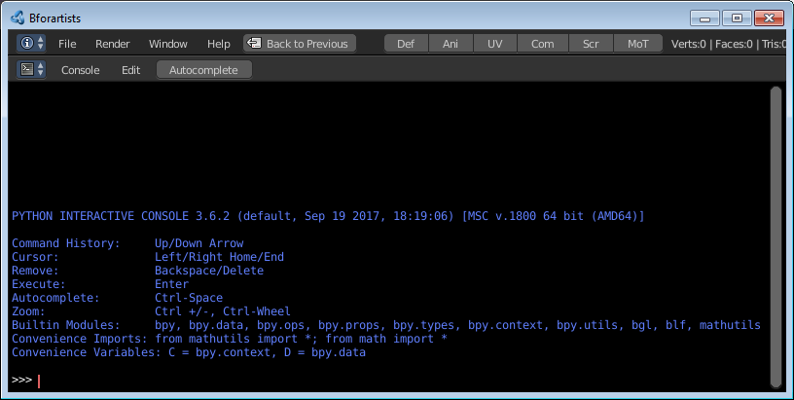
Toggle Maximize Area
Displays the editor maximized with menus.
To return to previous view press hotkey Ctrl Up Arrow, or reuse the menu item in the View menu.

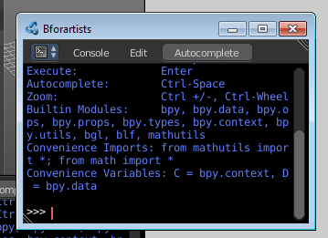
Duplicate Area into new Window
Duplicate Area into New Window makes the selected editor window floating. You can then drag it around at the monitor.
A separated window cannot be merged into the main window again. You have to close it when not longer needed.

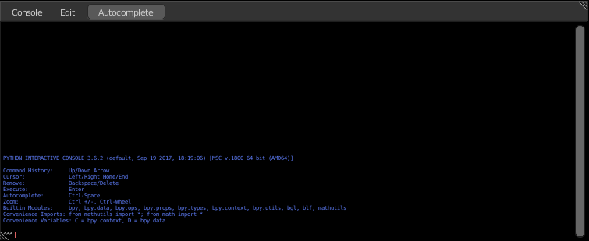
Zoom Text Out
Zooms out the text in the console window.

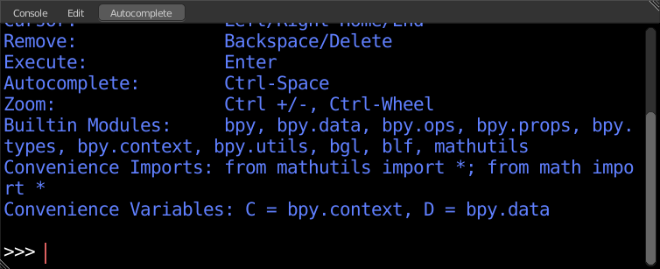
Zoom Text In
Zooms in the text in the console window.

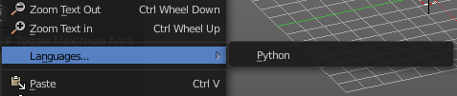
Languages
Languages is a sub menu where you can choose the language.
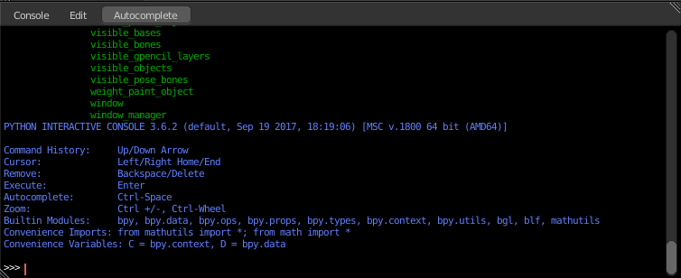
This menu looks pretty uselesss, since there is just one language available. But it has its useage. With a click at the Python button you can restart the console when you have lost yourself in the deeps of the api.

Paste
Pastes copied content

Copy
Copies selected content.

Copy as Script
Copies the whole content of the console as a script that can be pasted into the Text editor.

Clear Line
Clears the selected line(s)

Clear
Clears all lines. The blue help text remains.

Console Execute
The expressions in the python console are not read only. You can execute them like you would do from a script. This button executes a selected command.

Edit Menu
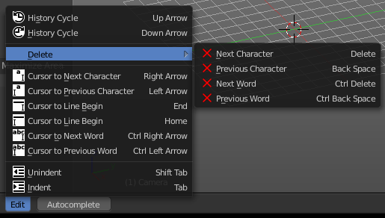
The Edit menu provides you with text specific functionality. Its content should be used by hotkeys. The menu is more to show that this functionality exists.

History Cycle
Cycles through the history. Up arrow cycles forwards through the history.
Down arrow cycles backwards through the history.
What does this mean? When you write some text, then add something more, delete something, then all this steps are entries in the history. And with History cycle you can access this steps.

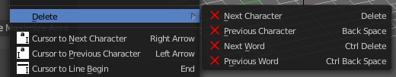
Delete
Delete is a sub menu with several delete methods.

Next character
Deletes the character beyond the caret.

Previous Character
Deletes the character before the caret.

Next Word
Deletes the word beyond the caret.

Previous Word
Deletes the word before the caret.

Cursor to Next character
Sets the caret in front of the next character.

Cursor to Previous Character
Sets the caret in front of the previous character.

Cursor to Line End
Sets the caret to line end.

Cursor to Line Begin
Sets the caret to line begin.

Cursor to Next word
Sets the caret in front of the next word.

Cursor to Previous word
Sets the caret in front of the previous word.

Unindent
Removes indention of the selected text.

Indent
Indents the selected text.

Autocomplete

Autocomplete is a functionality to autocomplete what you have written in the console. It lists for example all available bpy operators when you type in bpy.context.area. , and then hit the Autocomplete button. That way you can go through the whole bpy hierarchy down to what you need for your code, starting with bpy. , and having a look at what is available.
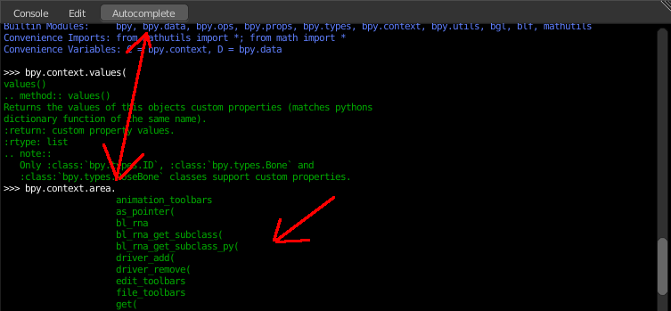

Usage

Accessing Built-in Python Console
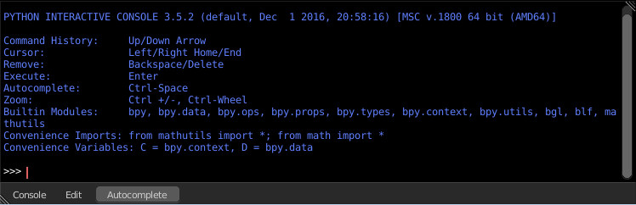
From the screen shot above, you will notice that by clicking at the Autocomplete button you can enable Auto-complete feature.
The command prompt is typical for Python 3.x, the interpreter is loaded and is ready to accept commands at the prompt >>>

First look at the Console Environment
To check what is loaded into the interpreter environment, type dir() at the prompt and execute it.
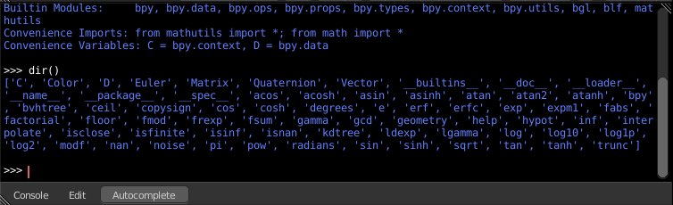
Following is a quick overview of the output
C
Quick access to bpy.context
D
Quick access to bpy.data
bpy
Top level Bforartists Python API module.
The rest of the commands are of various content. Most of them are mathematical expressions.

Auto Completion at work
Now, type bpy. and then press the Autocomplete button, and you will see the Console auto-complete feature in action.
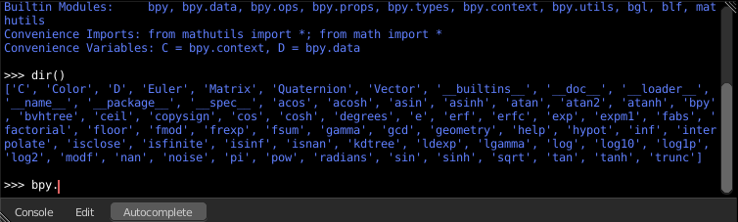
You will notice that a list of sub-modules inside of bpy appear. These modules encapsulate all that we can do with Bforartists Python API and are very powerful tools.
Lets list all the contents of bpy.app module.
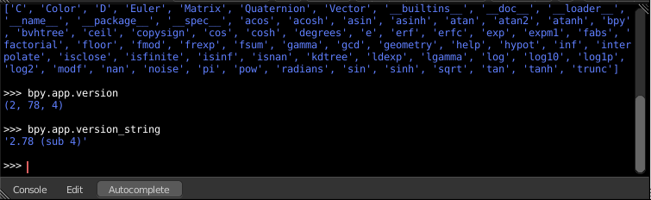
Notice the green output above the prompt where you enabled auto-completion. What you see is the result of auto completion listing. In the above listing all are module attribute names, but if you see any name end with ‘(‘, then that is a function.
We will make use of this a lot to help our learning the API faster. Now that you got a hang of this, lets proceed to investigate some of modules in bpy.

Before tinkering with the modules..
If you look at the 3D Viewport in the default Bforartists scene, you will notice some objects. We have added a cube here too.
- All objects exist in a context and there can be various modes under which they are operated upon.
- At any instance, only one object is active and there can be more than one selected objects.
- All objects are data in the Bforartists file.
- There are operators/functions that create and modify these objects.
For all the scenarios listed above (not all were listed, mind you..) the bpy module provides functionality to access and modify data.
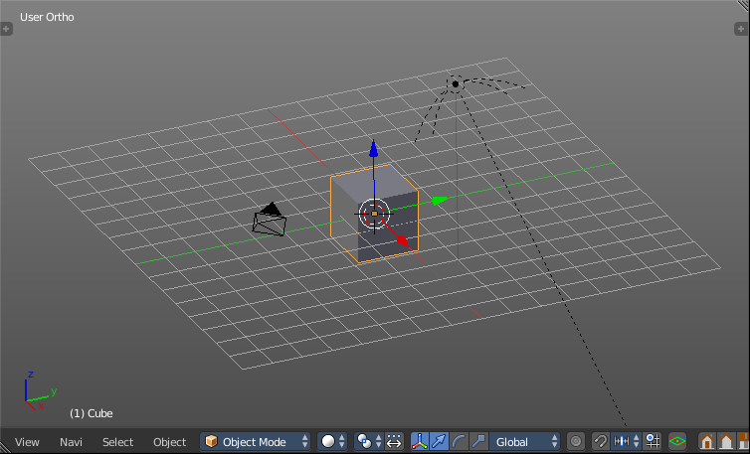

Examples

Note
For the commands below to show the proper output, make sure you have selected object(s) in the 3D view.

bpy.context
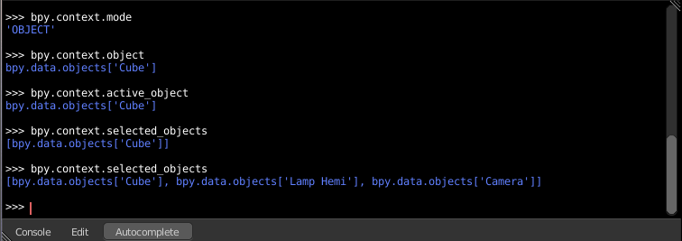

Try it out!
bpy.context.mode
Will print the current 3D View mode (Object, Edit, Sculpt etc.,)
bpy.context.object or bpy.context.active_object
Will give access to the active object in the 3D View
>>> bpy.context.object.location.x = 1
Change x location to a value of 1
>>> bpy.context.object.location.x += 0.5
Move object from previous x location by 0.5 unit
>>> bpy.context.object.location = (1, 2, 3)
Changes x, y, z location
>>> bpy.context.object.location.xyz = (1, 2, 3)
Same as above
>>> type(bpy.context.object.location)
Data type of objects location
>>> dir(bpy.context.object.location)
Now that is a lot of data that you have access to
bpy.context.selected_objects
Will give access to a list of all selected objects.
>>> bpy.context.selected_objects
... then press Ctrl-Spacebar
>>> bpy.context.selected_objects[0]
Prints out name of first object in the list
>>> [object for object in bpy.context.selected_objects if object != bpy.context.object]
Complex one... But this prints a list of objects not including the active object

bpy.data
bpy.data has functions and attributes that give you access to all the data in the Bforartists file.
You can access following data in the current Bforartists file: objects, meshes, materials, textures, scenes, screens, sounds, scripts, ... etc.
That’s a lot of data.

Try it out!
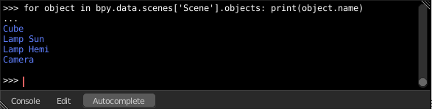

Exercise
>>> for object in bpy.data.scenes['Scene'].objects: print(object.name)
Return twice Prints the names of all objects belonging to the Bforartists scene with name “Scene”
>>> bpy.data.scenes['Scene'].objects.unlink(bpy.context.active_object)
Unlink the active object from the Bforartists scene named ‘Scene’
>>> bpy.data.materials['Material'].shadows

>>> bpy.data.materials['Material'].shadows = False

bpy.ops
The tool/action system in Bforartists is built around the concept of operators. These operators can be called directly from console or can be executed by click of a button or packaged in a python script. Very powerful they are..
For a list of various operator categories, click here
Lets create a set of five Cubes in the 3D Viewport. First, delete the existing Cube object by selecting it and pressing X

Try it out!
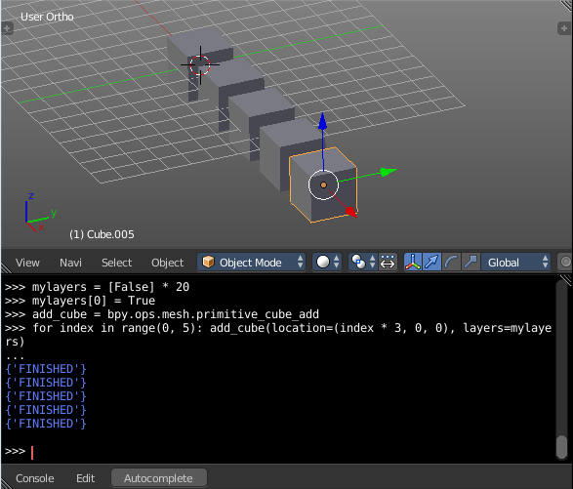
The following commands are used to specify that the objects are created in layer 1. So first we define an array variable for later reference:
>>> mylayers = [False] * 20
>>> mylayers[0] = True
We create a reference to the operator that is used for creating a cube mesh primitive
>>> add_cube = bpy.ops.mesh.primitive_cube_add
Now in a for loop, we create the five objects like this (In the screenshot above, I used another method) Press ENTER-KEY twice after entering the command at the shell prompt.
>>> for index in range(0, 5): add_cube(location=(index * 3, 0, 0), layers=mylayers)

